Writing Task on Reasons and Examples
Task 1
Organize the scrambled sentences for each of the following topics into an outline. The sentences are reasons, examples or other specific details, topic sentences, or concluding sentences. (p128 in the book)
Topic 1: Reasons not to own a Hummer
- To sum up, for the health of your bank balance as well as for the health of the environment, don’t buy a Hummer.
- Hummers are big gas hogs.
- The H2 model gets less than 10 miles per gallon of gas.
- In one year, a Hummer gives off 24,100 pounds of carbon dioxide, which is two to three times more than average cars give off.
- There are at least two reasons for not buying the huge, military-type vehicle called a Hummer.
- The U.S. government’s Environmental Protection Agency gives it a failing grade.
- When gas costs $3 per gallon, it costs $100 to fill up a Hummer’s big gas tank.
- Hummers are bad for the environment.

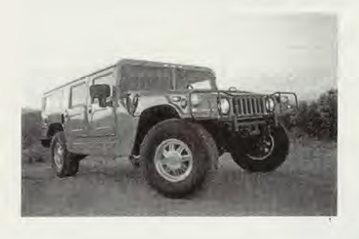 | 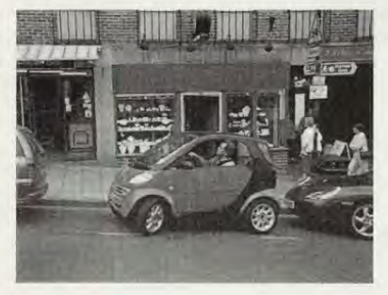

Topic 2: Reasons to own a Smart
- The Smart is easy on the wallet.
- The Smart will be the next “cool” car to own for several reasons.
- The design is eye-catching.
- It costs between $15,000 and $25,000.
- It has changeable door panels in stylish colors.
- It is only 8 feet, 2 1/2 inches (250 cm) long, which is the width of a street parking space.
- Its body is modern in design.
- You can park two or three Smarts side-by-side in a single street parking space.
- The European model gets 60 miles per gallon of gas, and the U.S. model 50 miles per gallon.
- The Smart is easy to park.
- For style, economy, and easy parking, the Smart is the car to buy.
Task 2
Add specific examples to an outline.
 | Outline A
Topic sentence | Joe's Diner is the best restaurant in town.
1st reason | A.The food is delicious.
example | 1.Joe's double cheeseburger is juicy and full of flavor.
example | 2.
2nd reason | B.The service is fast and cheerful.
example | 1.
example | 2.
3rd reason | C.The prices are low.
example | 1.
example | 2.
Concluding sentence | When you are hungry and in a hurry, try Joe's Diner for a fast, delicious, inexpensive meal served with a smile.

Task 3
Fill in the blanks with for example, for instance, or such as. Add commas where necessary. (There may be more than one correct answer.)
- San Francisco has several ethnic¹ neighborhoods ______North Beach (Italian), the Mission District (Hispanic), and Chinatown (Chinese).
- When you visit the ethnic neighborhoods of Miami, you feel that you are in a foreign country. _______in Little Havana you can easily imagine that you are in Cuba.
- Summers are much cooler in San Francisco than in Los Angeles._____ the average July temperature in San Francisco is about 65°F, but it is 85°F in Los Angeles.
- Mexico’s Yucatan Peninsula has many luxury beach resorts ________Cancun and Cozumel.
- The Yucatan is full of archaeological treasures ________the Mayan ruins at Chichen Itza and Tulum.

